IT2654 Systems Administration & Security

Tutorial 5

Discuss within your groups and prepare the answers to be presented in class.

- What is Secondary Logon? What is the main advantage?
Windows Secondary Logon allows administrators to log on with a non-administrator account to perform administrative tasks without logging off. It is a feature to run a task at higher privilege (admin rights)

Advantage: better security. If you have a computer and you log in as admin, if a hacker hacks into the systems, they will steal the admin account details, thereby doing a lot of damage. Secondary logon allows the ordinary account to run the admin task at a higher privilege. If a hacker hacks the system, they will only be able to get the ordinary user’s account details
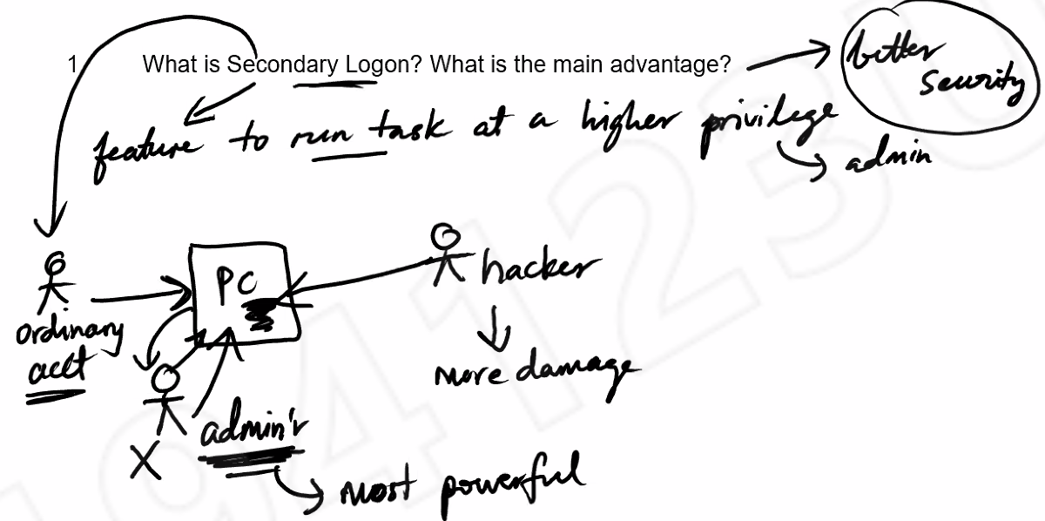
- What are the advantages of remote login? How does a client login remotely to the Windows server? What are the limitations?
Advantages
- Provide remote access to most configuration settings
- Diagnose a problem and test multiple solutions quickly
- Allow access to servers from anywhere in the world
- Perform time-consuming batch administrative jobs, such as tape backups
- Upgrade server applications and operating systems remotely
- Prevents direct access to the server

How does a client login remotely to the windows server?
- Open Control Panel, System Properties, Remote Settings, Select Allow Users to Connect Remotely
- Add users to Remote Desktop Users group and configure this group of users to allow remote log on. Client must be a member of the remote desktop user group.
- Clients will then have to run the remote desktop connection and key in the necessary information

Limitations
- Maximum 2 users can be granted access (to get more, need to buy additional)
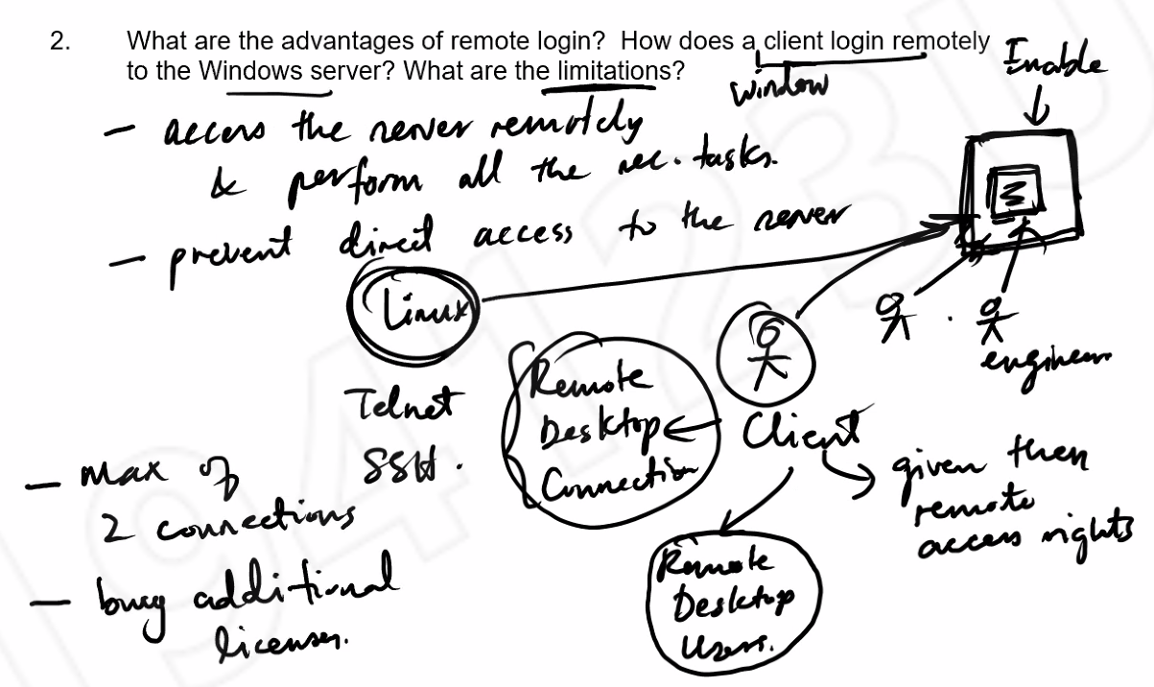
- Backups are important in the event of Disaster Recovery. Discuss the following aspects of backups:
- Onsite versus offsite backup
The site refers to the datacentre.

Onsite = backup is stored at the datacentre. Easy to restore, very fast since its within the vicinity. However, if the datacentre is destroyed, backup also destroyed.

Offsite = backup stored somewhere else. Even if datacentre is destroyed, backup is still ok. However, to restore to datacentre, you need to transport it which poses a security risk.
- Types of data to backup and their frequency
Operating system do they change a lot? no monthly basis
Applications do they change a lot? no monthly basis
Production data do they change a lot? yes daily basis
User data do they change a lot? yes daily basis
- Local versus network backup
Local: connected to the machine. This way is faster, and you can backup things like registry. Advantage: You only backup local machine
Network: your backup device is on the network. When you backup, data has to travel across network to backup device. Advantage: can backup other servers. Disadvantage: consumes bandwidth. E.g.: cloud backup
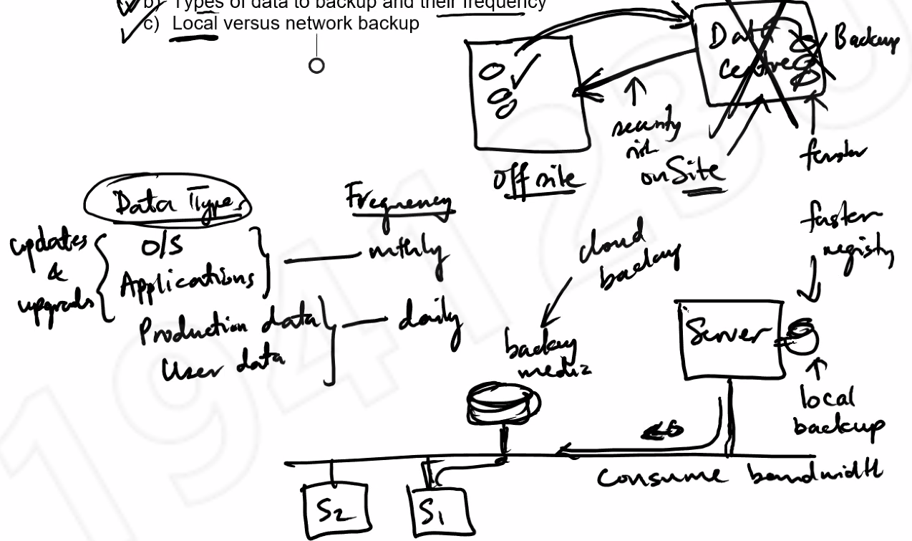
- Compare and describe the 3 types of backups available in Windows Server – Full, Incremental, and Differential. How is the archive bit affected in each of the backup?
1) Full backup (default)
- A backup of an entire system, including all system files, programs, and data files
- Changes each file’s archive attribute to show that it has been backed up
- Does not exclude anything, regardless of archive bit
- Reset the archive to 0
2) Incremental backup
- Only backs up files that are new or that have been updated (Backup changes since the last backup)
- Backs up only files that have the archive attribute marked
- Reset archive bit to 0
3) Differential backup
- Only back up files that changed up to last full backup.
- Will not reset archive bit to 0
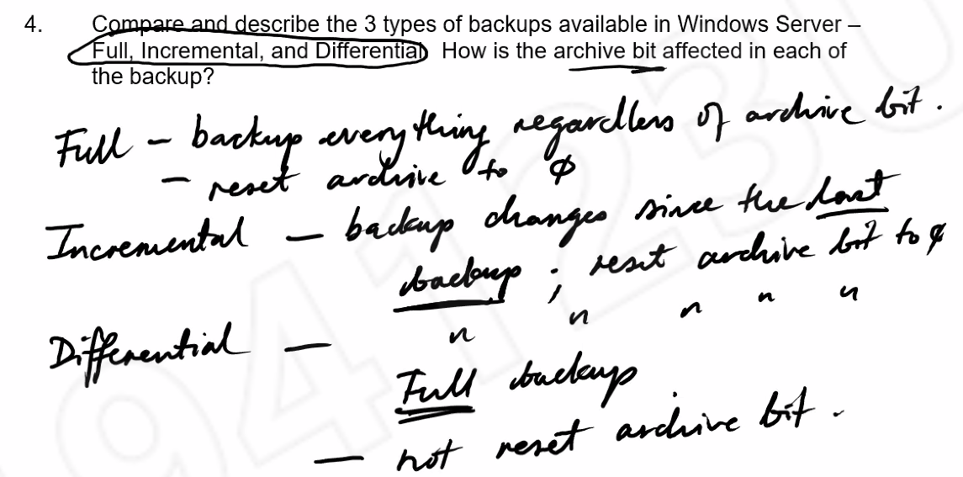
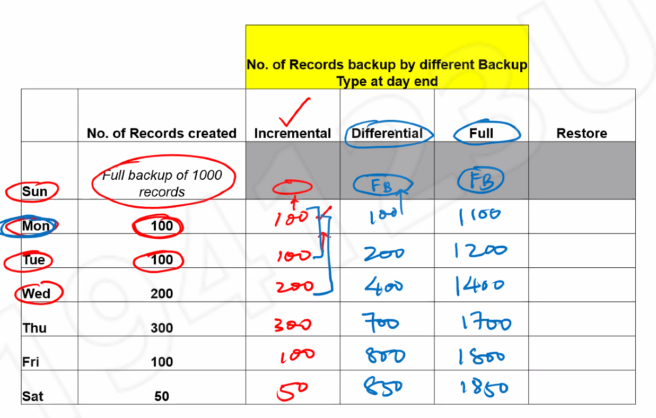
- What is Shadow copy and what its advantages?

- Purpose of this utility is to make recovery of user files in shared folders easy without requiring an administrator
- It is a bit like a snapshot. In the past, if the user loses a file from the shared folder, he will have to contact the administrator to restore the backup of the shared folder. With shadow copy, at certain times in the day, snapshots will be made of the shadow copy (a little like a history). User can then retrieve the shadow copy if they lose their file (inside their “previous” tab but only for Windows 7 onward). Even if the user is using the files, when the OS takes the snapshot, it can still create a shadow copy of the opened files.
Advantages:
- Restoration of accidentally deleted files
- Recovery of previous versions of files
- Comparison of previous version to current version
